**********************CSS CONCEPT******************

Note: for background image : pixcel.com

1. Font awesome link : <link rel="stylesheet" href="https://cdnjs.cloudflare.com/ajax/libs/font-awesome/4.7.0/css/font-awesome.min.css">

Just import from the website : <https://fontawesome.com/v4/icons/>

HOW TO CREATE A WEBSITE :

PROFREEHOST -> REGISTER -> Create a new account -> worldpress

1. HOW to keep container at the center of the screen

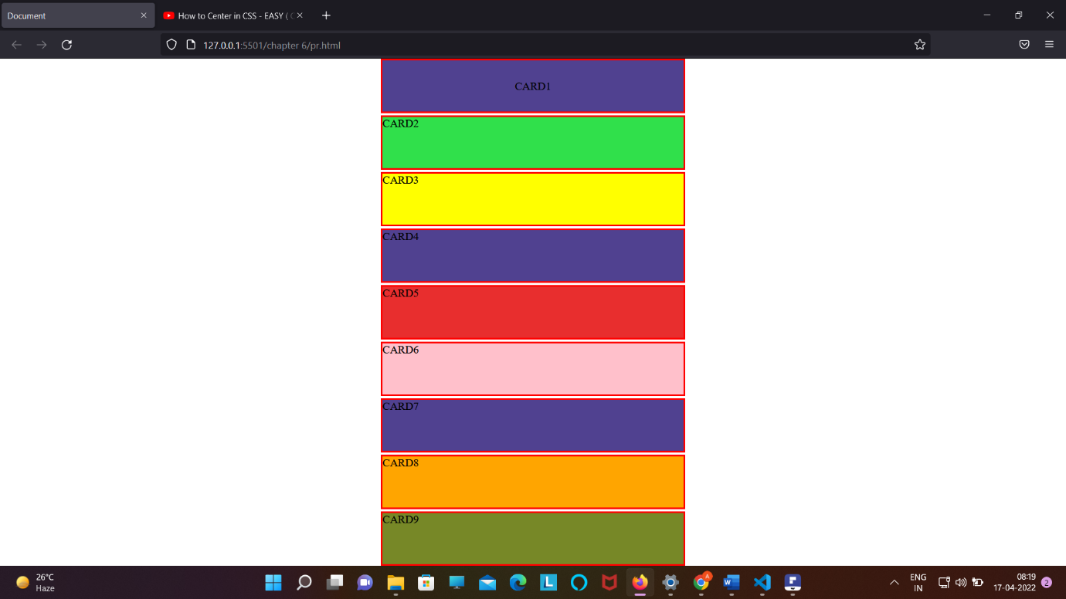

Margin : auto ;

2 . How to keep the text in the container at the center from top/right/bottom/left;

Display : flex;

Align-content : center;

Justify-content : center ;

3. justify-content :

Link : <https://www.w3schools.com/cssref/css3_pr_justify-content.asp>

3 . in order to not filling anything box :

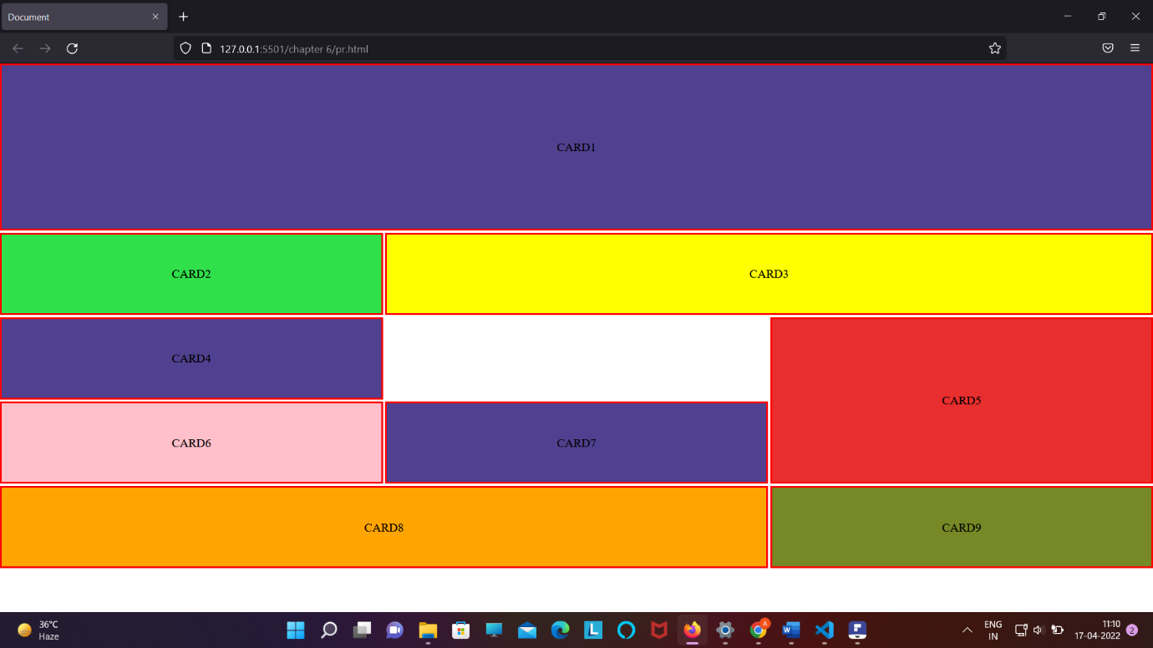

We need to use :

Display : grid;

Grid-template-area:

“ card1 . card2 “ /* bindi is ued to do such thing * /

4. top put any back ground image to full the screen or container to zooming image by keeping image at the center

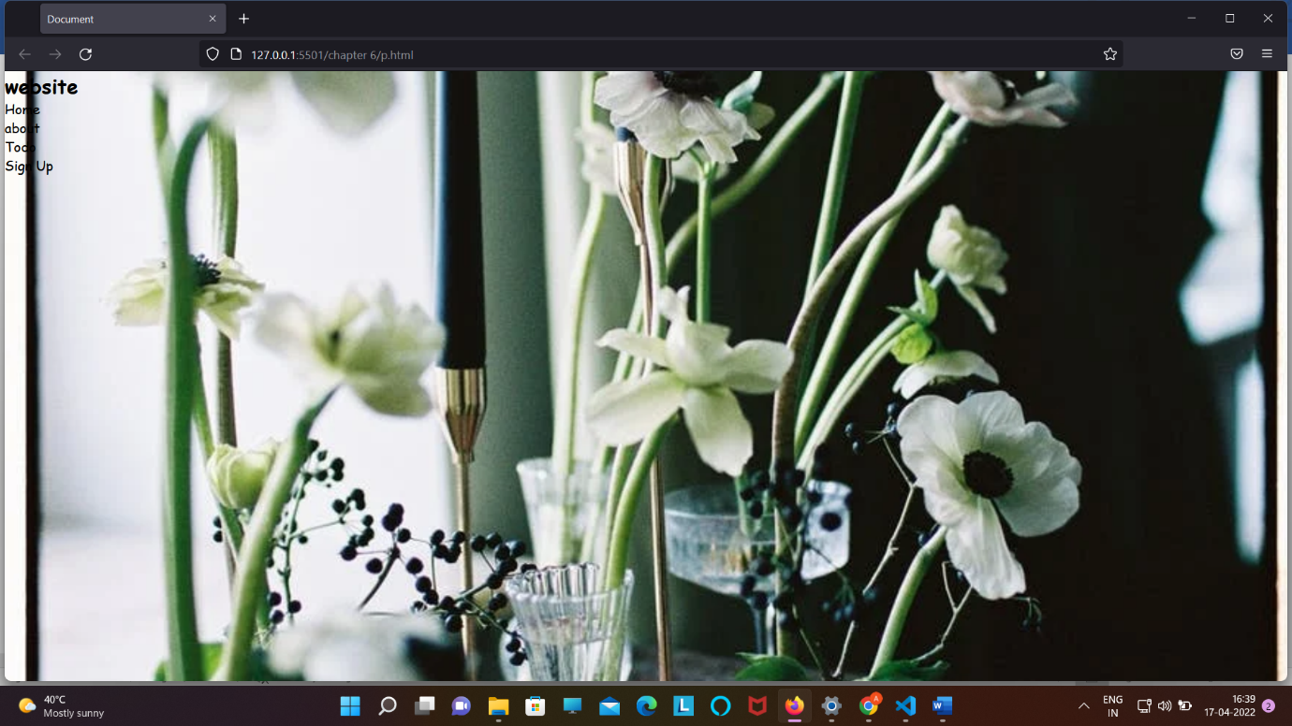

Step 1 : keep the image at the center (background-postion : center ;)

Step 2 : background-size : cover :

.headder{

*min-height*: 100vh;

*background*: url("https://images.pexels.com/photos/11677398/pexels-photo-11677398.jpeg?auto=compress&cs=tinysrgb&dpr=2&h=650&w=940") no-repeat center;

*background-size*: cover;

*color*: black;

height : 110vh;

}

5 . DISPLAY PROPERTY :

A . display: inline ;

B. display : block ;

C . display: inline-block ; // it will make the item of the container to display in line but it will a create a block for each element

D . display: inline-flex : /* it will make the all item of the container to display in line and it will not going to create any block ;

There is only one main difference between the **inline-block** and **inline-flex**:   
**inline-block:** Create specific block for each element under its section maintain the structure of each element.   
**inline-flex:** Does not reserved any specific space in normal form.

6. another way to making nav bar like ( SABKO CENTER MAI LAKAR BIKHARNA )

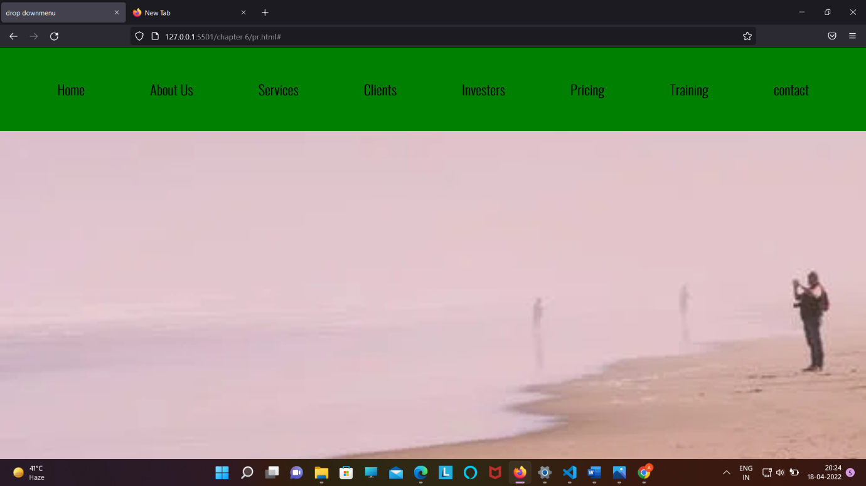

<!DOCTYPE html>

<html lang="en">

<head>

    <meta charset="UTF-8">

    <meta http-equiv="X-UA-Compatible" content="IE=edge">

    <meta name="viewport" content="width=device-width, initial-scale=1.0">

    <title>drop downmenu</title>

    <link rel="stylesheet" href="p.css">

</head>

<body>

    <header>

        <nav>

            <ul class="nav_bar">

                <li><a href="#">Home</a></li>

                <li><a href="#">About Us</a></li>

                <li><a href="#">Services</a></li>

                <li><a href="#">Clients</a></li>

                <li><a href="#">Investers</a></li>

                <li><a href="#">Pricing</a></li>

                <li><a href="#">Training</a></li>

                <li><a href="#">contact</a></li>

            </ul>

        </nav>

    </header>

</body>

</html>

.nav_bar{

Text-align :center;

}

.nav_bar li{

Display : inline-flex;

Margin :1rem;

Padding :1rem;

}

6 . button degin code :

.btn{

*display*: inline-block;

*border*: none;

*outline*: none;

*cursor*: pointer;

}

.btn-headline{

*padding*: 1rem 2rem;

*margin*: top 1rem;

*font-weight*: 600;

}

7. To place any thing wrt to parents then :

First : we give position : relative : /* to parents */

Second : we give position : absolute ; /* to element which we want to place * / and measurement will be in percentage for element which we want to place .

Parent :

.header {

*position*: relative;

element :

.wirteup {

*text-align*: center;

*position*: absolute;

*top*: 50%;

*left*: 50%;

*transform*: translate(-50%, -50%);

}

8 . setting container in every item we are goning to get

.container {

*max-width*: 1200px;

*margin*: auto;

*width*: 90%;

}

9 . to make input attribute in single line :

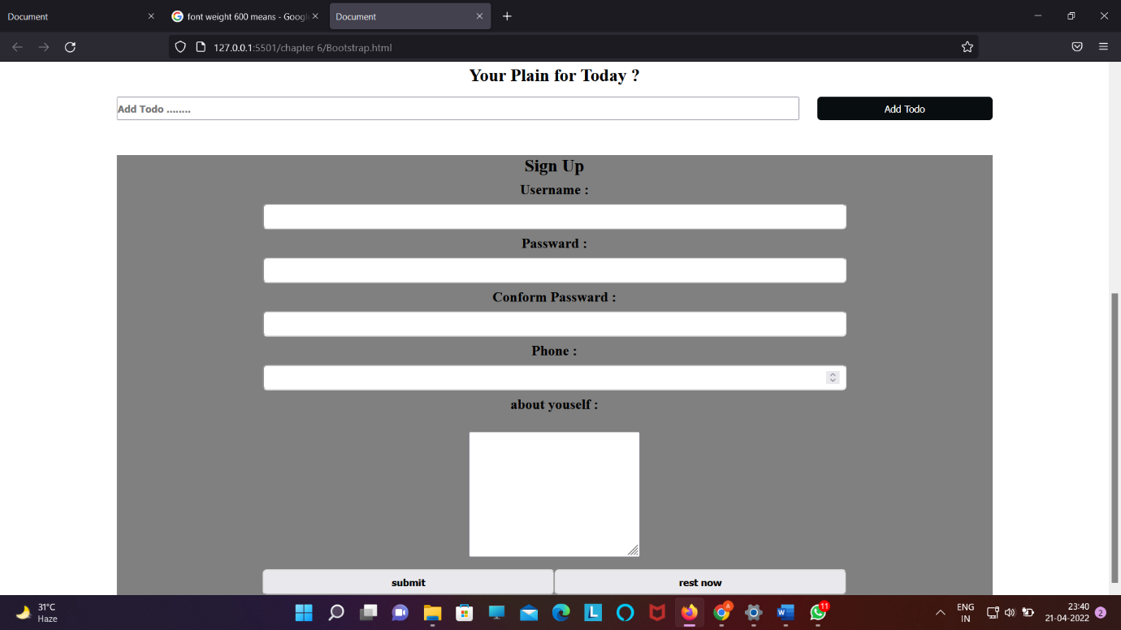

Lable{

Display:block;

}

Input{

Display : block;

}

.section-signup label,

input {

*display*: block;

}

When ever we are writing para remember to use :

Line-height:

Letter-spacing:

<br>

*line-height*: 1.5rem;

*letter-spacing*: 0.1rem;

*font-family*: Arial;

During making nav bar or button try to use :to bring animation

*transition*: 0.3s ease-in;

.section-btn button:hover{

*background-color*: white;

*color*: orange;

}

* We can control the width and height of image by :
* <img src="Madhubala1957.png" height=500px" width="1200px" alt="...">
* USE OF :

1 . :firstchild

2.lastchild

3. nth-child(write child no)

🡺 Use of z-index :

Note z index will only going to work when we have given position : relative / absolute / fixed / sticky

Use of Opacity :

Note – it can take value between 0 to 1;

0 means : note visible ;

1 means : fully visible ;

Use of overflow :

Link : <https://www.w3schools.com/css/css_overflow.asp>

Note :

If we want to align any box into top , bottom , left and right if we are unable to do with text-align the

We can use :

Position : relative / absolute;

Top / bottom / left / right = 0;

Box-shadow :horizontal-offset ,vertical-offset , blur , shadow-spread ,color ;

Link-to stdy : <https://www.w3schools.com/cssref/css3_pr_box-shadow.asp>

Agar kisi ko center mail lana(from all direction top,right,bottom,left ) hai too :

Step-> ek div banayenge div.container

Step 2 -> iske under jisko center mail ana hai wo likhege div.items

.css :

.container{ display: flex; justify-content :center ; align-items:center;

}

.items{ text-align: center ; max-width :80%;

}

** sticky nav_bar tutorial : check project

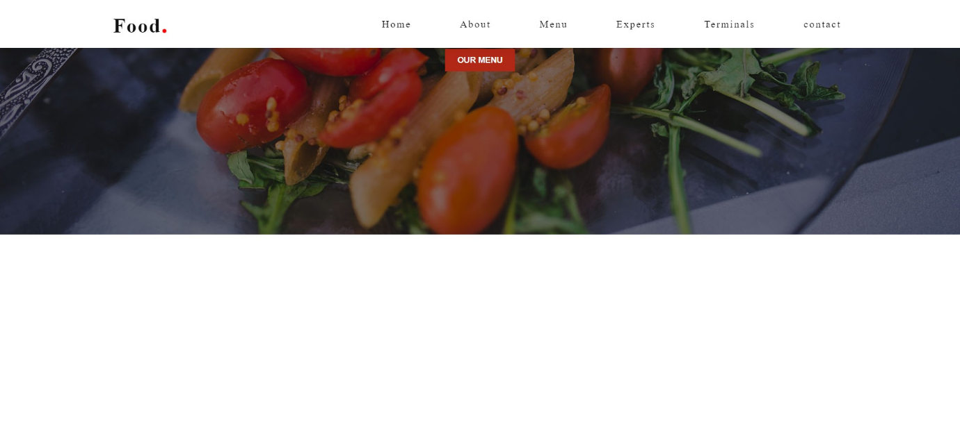

*const* sticy_header = () *=>* {

*const* container = document.querySelector(".container");

  window.addEventListener("scroll", () *=>* {

    container.classList.toggle("sticky", window.scrollY > 0);

  });

};

sticy_header();

css : .sticky{

*background*: #fff;

*padding*: 15px 15px ;

*box-shadow*: 0 5px 20px rgba(0,0,0,0.05);

}

.sticky .logo{

*color*:#111;

}

.sticky .nav-items a{

*color*: #111;

}

*** NOTE : IF WE WANT TO KEEP SPACE ALL ARROUND ANY THING IN THE CONTAINER That can be done by:

Applying :

.container{

Padding : 100px;

}

Eg : in about section : section{padding :100px } ;

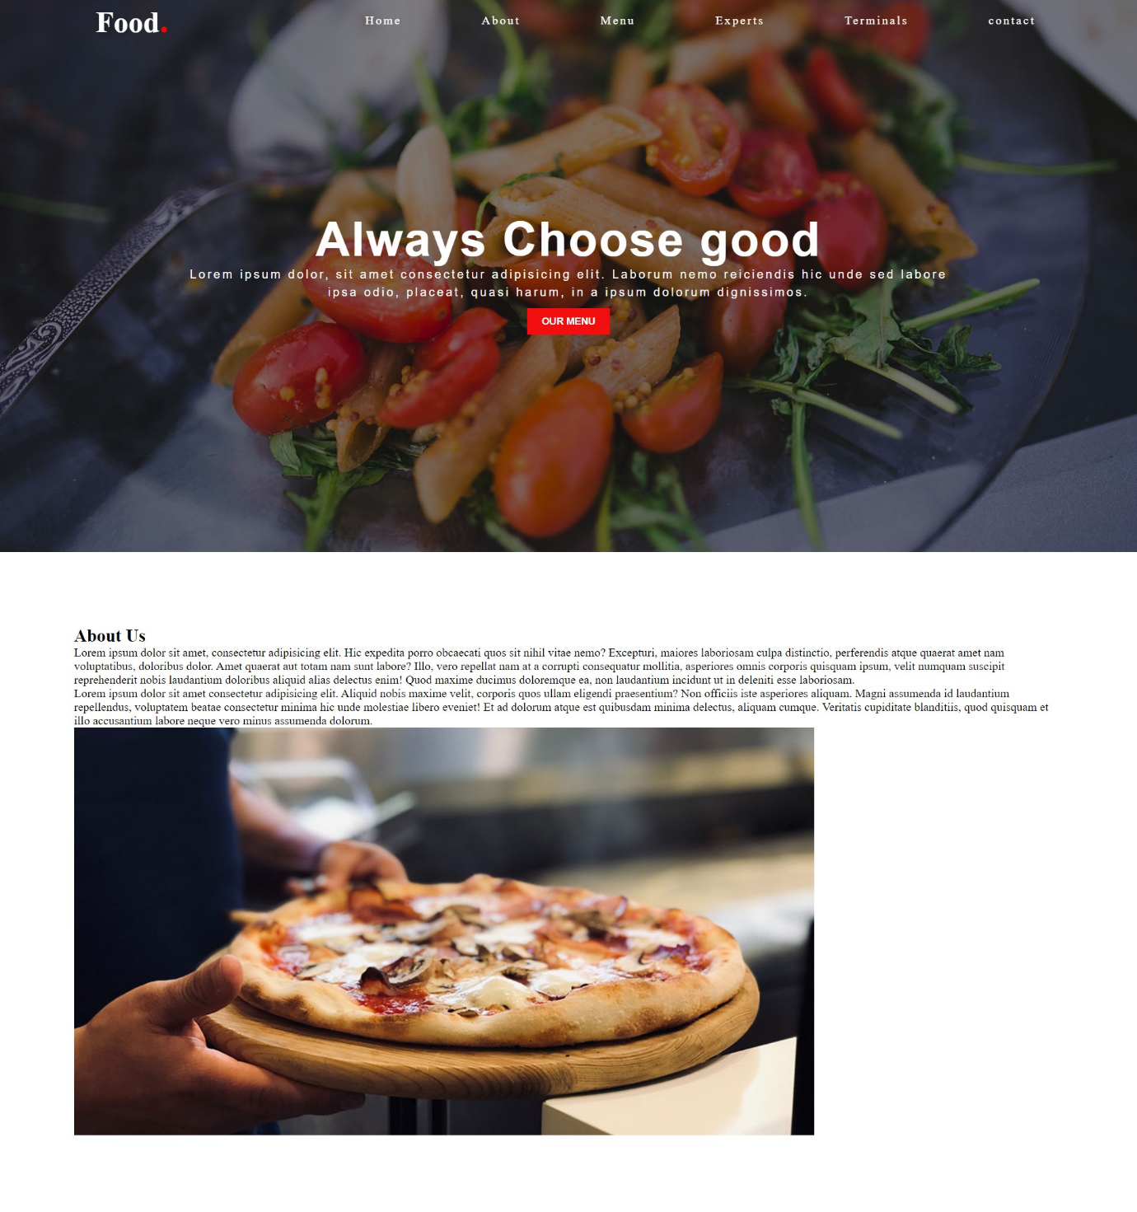

To put any thing at the center of the box:

Position : absolute ;

top : 50%;

left : 50%;

transform :translate(-50%,-50% ) ;